The Annual Quality Assurance Report (AQAR) of the IQAC 2009 - 2010

Part – A
1. Details of the Institution
Adusumilli Gopala Krishnaiah Sugarcane Growers Siddhartha Degree College of Arts & Science, Vuyyuru
1.1 Name of the Institution
College Road
1.2 Address Line 1
Near Kota
Address Line 2
Vuyyuru
City/Town
Andhra Pradesh
State
521 165
Pin Code
principal@agsgsc.edu.in
Institution e-mail address
08676-233267
Contact Nos.
B. Venkata Rayudu
Name of the Head of the Institution:
08676-233267
Tel. No. with STD Code:
9866222628
Mobile:

J. Nageswara Rao
Name of the IQAC Co-ordinator:

Mobile:
9948082145
iqac@agsgsc.edu.in
IQAC e-mail address:
APCOGN12986

1.3 NAAC Track ID (For ex. MHCOGN 18879)
EC/41/72 dated 10-02-2007
1.4 NAAC Executive Committee No. & Date:
(For Example EC/32/A&A/143 dated 3-5-2004.
This EC no. is available in the right corner- bottom
of your institution’s Accreditation Certificate)

www.agsgsc.edu.in
1.5 Website address:
http://www.agsgsc.edu.in/AQAR2009-10.doc

Web-link of the AQAR:
For ex. http://www.ladykeanecollege.edu.in/AQAR2009-10.doc
1.6 Accreditation Details
Sl. No. | Cycle | Grade | CGPA | Year of Accreditation | Validity Period
1 | 1st Cycle | B + | 77.5 | 10/02/2007 | 5 years

09/07/2007
1.7 Date of Establishment of IQAC : DD/MM/YYYY

2009-10
1.8 AQAR for the year (for example 2008-09)

1.9 Details of the previous year’s AQAR submitted to NAAC after the latest Assessment and Accreditation by NAAC ((for example AQAR 2010-11submitted to NAAC on 12-10-2011)
- AQAR 2010-2011 submitted to NAAC (DD/MM/YYYY)
1.10 Institutional Status

✓

University State Central Deemed Private
✓

Affiliated College Yes No
Constituent College Yes No

✓

Autonomous college of UGC Yes No

✓

✓

Regulatory Agency approved Institution Yes No
(eg. AICTE, BCI, MCI, PCI, NCI)
✓

Type of Institution Co-education Men Women

✓

Urban Rural Tribal

✓

✓

✓

Financial Status Grant-in-aid UGC 2(f) UGC 12B
✓

Grant-in-aid + Self Financing Totally Self-financing

1.11 Type of Faculty/Programme
✓

✓

✓

Arts Science Commerce Law PEI (Phys Edu)

TEI (Edu) Engineering Health Science Management

Others (Specify)

1.12 Name of the Affiliating University (for the Colleges)
Acharya Nagarjuna University, Guntur

1.13 Special status conferred by Central/ State Government-- UGC/CSIR/DST/DBT/ICMR etc

Autonomy by State/Central Govt. / University

University with Potential for Excellence UGC-CPE

DST Star Scheme UGC-CE

UGC-Special Assistance Programme DST-FIST

UGC-Innovative PG programmes Any other (Specify)

UGC-COP Programmes

2. IQAC Composition and Activities
07
2.1 No. of Teachers
01
2.2 No. of Administrative/Technical staff
02
2.3 No. of students
2.4 No. of Management representatives
NIL
01
2.5 No. of Alumni
2. 6 No. of any other stakeholder and
NIL
community representatives
01
2.7 No. of Employers/ Industrialists

03
2.8 No. of other External Experts
2.9 Total No. of members
15
02
2.10 No. of IQAC meetings held
03
02
2.11 No. of meetings with various stakeholders: No. Faculty
01

Non-Teaching Staff Students Alumni Others
2.12 Has IQAC received any funding from UGC during the year? Yes No

✓

If yes, mention the amount
2.13 Seminars and Conferences (only quality related)
(i) No. of Seminars/Conferences/ Workshops/Symposia organized by the IQAC

✓

Total Nos. International National State Institution Level
(ii) Themes

2.14 Significant Activities and contributions made by IQAC
- If gives valuable suggestions for activities and maintain the quality of education.
- IQAC looks after academic activities including teaching learning evaluations.
- Seminars, conferences and guest lectures arrange.
- Exit meeting for last year students.

2.15 Plan of Action by IQAC/Outcome
The plan of action chalked out by the IQAC in the beginning of the year towards quality enhancement and the outcome achieved by the end of the year *

Plan of Action | Achievements
To train the students of rural background in communicative skills and soft skills in English to meet global competencies. | English Lab was established.
To conduct guest lectures, students seminars, workshops, field trips and staff seminars | Guest lectures were arranged by some departments
To encourage the various department to conduct invited talks by experts from respective fields | CGC has encouraged the students for competitive examination and career selections
To start a PG Course. | Started PG Chemistry
To prepare plans for the development of infrastructure. | Plans have been prepared for the construction of additional class rooms and laboratories.
✓

2.15 Whether the AQAR was placed in statutory body Yes No

Management Syndicate Any other body
Provide the details of the action taken
Management approved AQAR and encouraged teachers for additional qualifications and research work.

Part – B
Criterion – I
1. Curricular Aspects
1.1 Details about Academic Programmes
Level of the Programme | Number of existing Programmes | Number of programmes added during the year | Number of self-financing programmes | Number of value added / Career Oriented programmes
PhD | - | - | - | -
PG | - | 01 | - | -
UG | 03 | - | - | -
PG Diploma | - | - | - | -
Advanced Diploma | - | - | - | -
Diploma | - | - | - | -
Certificate | - | - | - | -
Others | - | - | - | -
Total | 03 | 01 | - | -

Interdisciplinary | - | - | - | -
Innovative | - | - | - | -

1.2 (i) Flexibility of the Curriculum: CBCS/Core/Elective option / Open options
(ii) Pattern of programmes:
Pattern | Number of programmes
Semester | ✓ (PG)
Trimester | -
Annual | ✓ (UG)

✓

✓

✓

1.3 Feedback from stakeholders* Alumni Parents Employers Students
(On all aspects)

✓

Mode of feedback : Online Manual Co-operating schools (for PEI)

1.4 Whether there is any revision/update of regulation or syllabi, if yes, mention their salient aspects.
As an affiliated college, University revision / update has been followed

1.5 Any new Department/Centre introduced during the year. If yes, give details.
Nil

Criterion – II
2. Teaching, Learning and Evaluation
2.1 Total No. of permanent faculty
Total | Asst. Professors | Associate Professors | Professors | Others
19 | - | - | - | 19
-
2.2 No. of permanent faculty with Ph.D.
2.3 No. of Faculty Positions Recruited (R) and Vacant (V) during the year
Asst. Professors |  | Associate Professors |  | Professors |  | Others |  | Total
R | V | R | V | R | V | R | V | R | V
- | - | - | - | - | - | - | 13 | - | 13

2.4 No. of Guest and Visiting faculty and Temporary faculty

2.5 Faculty participation in conferences and symposia:

No. of Faculty | International level | National level | State level
Attended Seminars/ Workshops | - | - | -
Presented papers | - | - | -
Resource Persons | - | - | -

2.6 Innovative processes adopted by the institution in Teaching and Learning:
- Power point presentation
- Use of ICT in teaching, presentation and interactive seminars of the students.

2.7 Total No. of actual teaching days
180
during this academic year

2.8 Examination/ Evaluation Reforms initiated by
-
the Institution (for example: Open Book Examination, Bar Coding,
Double Valuation, Photocopy, Online Multiple Choice Questions)
-
-
-
2.9 No. of faculty members involved in curriculum
restructuring/revision/syllabus development
as member of Board of Study/Faculty/Curriculum Development workshop
80
2.10 Average percentage of attendance of students

2.11 Course/Programme wise
distribution of pass percentage :

Title of the Programme | Total no. of students appeared | Division
Title of the Programme | Total no. of students appeared | Distinction % | I % | II % | III % | Pass %
B.A. | 51 | - | 21.56 | 41.16 | 31.36 | 94.11
B.Com. | 55 | 1.82 | 18.2 | 49.09 | 20.02 | 89.09
B.Sc. | 87 | 30.05 | 42.09 | 14.05 | 9.17 | 94.25
B.Sc. Computers | 35 | 42.86 | 51.43 | - | 5.71 | 100
2.12 How does IQAC Contribute/Monitor/Evaluate the Teaching & Learning processes :
IQAC members interact and co-operate with teachers for quality enhancement.
2.13 Initiatives undertaken towards faculty development
Faculty / Staff Development Programmes | Number of faculty  benefitted
Refresher courses | 2
UGC – Faculty Improvement Programme | -
HRD programmes | -
Orientation programmes | 1
Faculty exchange programme | -
Staff training conducted by the university | -
Staff training conducted by other institutions | -
Summer / Winter schools, Workshops, etc. | -
Others
2.14 Details of Administrative and Technical staff
Category | Number of Permanent  Employees | Number of Vacant  Positions | Number of permanent positions filled during the Year | Number of positions filled temporarily
Administrative Staff | 17 | 13 | - | 18
Technical Staff | - | - | - | -
Criterion – III
3. Research, Consultancy and Extension
3.1 Initiatives of the IQAC in Sensitizing/Promoting Research Climate in the institution
- IQAC encourage teachers to undertake major / minor research projects sponsored by UGC and provide necessary facilities and assistance.
- IQAC encourages teachers to do Ph.D., M.Phil., and refresher course, Orientation Programme and workshops.

3.2 Details regarding major projects
 | Completed | Ongoing | Sanctioned | Submitted
Number | - | - | - | -
Outlay in Rs. Lakhs | - | - | - | -

3.3 Details regarding minor projects
 | Completed | Ongoing | Sanctioned | Submitted
Number | - | - | - | -
Outlay in Rs. Lakhs | - | - | - | -

3.4 Details on research publications
 | International | National | Others
Peer Review Journals | - | - | -
Non-Peer Review Journals | - | - | -
e-Journals | - | - | -
Conference proceedings | - | - | -

3.5 Details on Impact factor of publications:
-
-
-
-
Range Average h-index Nos. in SCOPUS
3.6 Research funds sanctioned and received from various funding agencies, industry and other organisations
Nature of the Project | Duration  Year | Name of the  funding Agency | Total grant  sanctioned | Received
Major projects | - | - | - | -
Minor Projects | - | - | - | -
Interdisciplinary Projects | - | - | - | -
Industry sponsored | - | - | - | -
Projects sponsored by the University/ College | - | - | - | -
Students research projects  (other than compulsory by the University) | - | - | - | -
Any other(Specify) | - | - | - | -
Total | - | - | - | -

3.7 No. of books published i) With ISBN No. Chapters in Edited Books
-

-
-

ii) Without ISBN No.
3.8 No. of University Departments receiving funds from
UGC-SAP CAS DST-FIST
-

-

-

-

-

DPE DBT Scheme/funds
3.9 For colleges Autonomy CPE DBT Star Scheme
-

-

-

INSPIRE CE Any Other (specify)
-

-

-

-

3.10 Revenue generated through consultancy

3.11 No. of conferences organized by the Institution
Level | International | National | State | University | College
Number | - | - | - | - | -
Sponsoring agencies | - | - | - | - | -

3.12 No. of faculty served as experts, chairpersons or resource persons
-

-

-

3.13 No. of collaborations International National Any other
-

3.14 No. of linkages created during this year
3.15 Total budget for research for current year in lakhs :
-

-

From Funding agency From Management of University/College
Total
-

3.16 No. of patents received this year
Type of Patent |  | Number
National | Applied | -
National | Granted | -
International | Applied | -
International | Granted | -
Commercialised | Applied | -
Commercialised | Granted | -

3.17 No. of research awards/ recognitions received by faculty and research fellows
Of the institute in the year
Total | International | National | State | University | Dist | College
- | - | - | - | - | - | -

3.18 No. of faculty from the Institution
-

who are Ph. D. Guides
and students registered under them
-

3.19 No. of Ph.D. awarded by faculty from the Institution
-

3.20 No. of Research scholars receiving the Fellowships (Newly enrolled + existing ones)
-

-

-

JRF SRF Project Fellows Any other
-

3.21 No. of students Participated in NSS events:
300
-

University level State level
National level International level
-

-

3.22 No. of students participated in NCC events:
70
6

University level State level
20

National level International level
-

3.23 No. of Awards won in NSS:
-

University level State level
-

National level International level
-

-

3.24 No. of Awards won in NCC:
University level State level
-

-

National level International level
-

-

3.25 No. of Extension activities organized
-

-

University forum College forum
-

2

-

NCC NSS Any other

3.26 Major Activities during the year in the sphere of extension activities and Institutional Social Responsibility
Apart in the regular work, a number of faculty and students actively take part in various social activities through NSS, NCC and blood donors club.
Clean and Green programme was arranged in and outside the campus.

Criterion – IV
4. Infrastructure and Learning Resources
4.1 Details of increase in infrastructure facilities:
Facilities | Existing | Newly created | Source of Fund | Total
Campus area | 12.93 | - | - | 12.93
Class rooms | 18 | 3 | - | 21
Laboratories | 11 | 1 | - | 11
Seminar Halls | 1 | - | - | 1
No. of important equipments purchased (≥ 1-0 lakh) during the current year. | - | - |  | -
Value of the equipment purchased during the year (Rs. in Lakhs) | 5,98,768 | - | UGC & Mang. | 5,98,768
Others | - | - | - | -

4.2 Computerization of administration and library
Computerization of administration and library is under process.
Started Net Resource Centre for students

4.3 Library services:
 | Existing |  | Newly added |  | Total
 | No. | Value | No. | Value | No. | Value
Text Books and  Reference Books | 1682 | 2,49,411 | 881 | 4,49,500 | 2563 | 6,98,911
e-Books | - | - | - | - | - | -
Journals | 180 | 43,575 | 60 | 18,533 | 240 | 62,108
e-Journals | - | - | - | - | - | -
Digital Database | - | - | - | - | - | -
CD & Video | 70 | 7,000 | 50 | 5000 | 120 | 12,000
Others (specify) | - | - | - | - | - | -

4.4 Technology up gradation (overall)
 | Total Computers | Computer Labs | Internet | Browsing Centres | Computer Centres | Office | Depart-ments | Others
Existing | 22 | 02 | - | - | - | - | - | -
Added | 03 | - | 5 | 01 | - | 1 | - | -
Total | 25 | 02 | 5 | 01 | - | 1 | - | -
4.5 Computer, Internet access, training to teachers and students and any other programme for technology
upgradation (Networking, e-Governance etc.)
Our computer department arranged classes for teaching and non-teaching staff and students
1) for technology upgradation 2) to learn fundamentals of computers.

4.6 Amount spent on maintenance in lakhs :
-
i) ICT
0.25
ii) Campus Infrastructure and facilities
-

iii) Equipments
-

iv) Others

0.25
Total :

Criterion – V
5. Student Support and Progression
5.1 Contribution of IQAC in enhancing awareness about Student Support Services
The IQAC plays an important role in enhancing awareness of student support service. Awareness brought through
- Calendar
- Department and College notice board
- Parent – teachers association
- Public addressing system.
- Support for slow learners by arranging remedial classes in different subjects.

5.2 Efforts made by the institution for tracking the progression
Our placement cell encourages outgoing students to visualize the starting of their own enterprises and become active contributes to the nation GDP.

5.3 (a) Total Number of students
UG | PG | Ph. D. | Others
825 | 30 | - | -

(b) No. of students outside the state
-
-
(c) No. of international students

Men Women
No | %
413 | 50.06
No | %
412 | 49.94
Last Year |  |  |  |  |  | This Year
General | SC | ST | OBC | Physically Challenged | Total | General | SC | ST | OBC | Physically Challenged | Total
243 | 222 | 14 | 349 | 4 | 832 | 217 | 222 | 15 | 369 | 2 | 825
Demand ratio 88.58 Dropout % 9.44

5.4 Details of student support mechanism for coaching for competitive examinations (If any)
- The institution facilitates student progression to higher level of education or towards employment through the proper placements in all the fields so that the students get a job as well as the chance of higher education. The college form time to time makes arrangements for guest lectures.

20
No. of students beneficiaries

5.5 No. of students qualified in these examinations -
-
-
-
-
NET SET/SLET GATE CAT
IAS/IPS etc State PSC UPSC Others
-
-
-
-

5.6 Details of student counselling and career guidance
The counselling cell makes adequate arrangements for the guidance of the students during the time of admissions. A choice of the career and the doubts of the students are listened to very carefully and solutions to the problems are provided.
The college provides the personal counselling for students. The teachers concerned is very supportive in guiding them to overcome their problems with tend to bring the inferiority complex in them. The teachers try to remedy such situation through proper counselling. They are inspired to become better human beings.

15
No. of students benefitted

5.7 Details of campus placement
On campus |  |  | Off Campus
Number of Organizations Visited | Number of Students Participated | Number of Students Placed | Number of Students Placed
- | - | - | -

5.8 Details of gender sensitization programmes
Centre for women’s welfare sensitizes the students to develop a healthy relationships with the opposite gender. This cell creates a awareness of the socio cultural, political and biological complexities of the issues. It enhances the understanding of the other gender.

5.9 Students Activities
5.9.1 No. of students participated in Sports, Games and other events
20
-
-
State/ University level National level International level

No. of students participated in cultural events
15
-
-
State/ University level National level International level

5.9.2 No. of medals /awards won by students in Sports, Games and other events
-
-
5
Sports : State/ University level National level International level
3
-
-
Cultural: State/ University level National level International level

5.10 Scholarships and Financial Support
 | Number of  students | Amount  (Rs.)
Financial support from institution  Siddhartha Foundation  Student Aid Fund | 15  12 | 58,850/-  7,200/-
Financial support from government | 752 | 39,50,241/-
Financial support from other sources | - | -
Number of students who received International/ National recognitions | - | -

5.11 Student organised / initiatives
-
-
-
Fairs : State/ University level National level International level
-
-
-
Exhibition: State/ University level National level International level

-
5.12 No. of social initiatives undertaken by the students

5.13 Major grievances of students (if any) redressed:
Increased the no. of reference books and book bank.
Arrangements of bus facility.

Criterion – VI
6. Governance, Leadership and Management
6.1 State the Vision and Mission of the institution
Vision
- To prepare the youth of this rural area for a bright future in this globalised world training them in knowledge and skills that can make them highly qualified human resources and to give a value base to their education to make them responsible citizens.
Mission
- To organize more number of Add-on/Certificate programmes.
- To encourage student participation in various co-curricular and extracurricular activities oriented towards developing interpersonal skills and to provide value oriented education.
- To involve the students in various socio-economic/community-oriented programmes to make them responsible shareholders of the progress of the community.
- To involve the teachers and students in the programmes of improving the health and hygienic conditions of the community.

6.2 Does the Institution has a management Information System
Yes

6.3 Quality improvement strategies adopted by the institution for each of the following:
6.3.1 Curriculum Development
- Faculty members active participated in curriculum development programme of the university.
- Started PG (Organic Chemistry).
- Introduced instrumentation practicals for final year B.Sc. students.

6.3.2 Teaching and Learning
Feedback, remedial classes, seminars, ICT and well stock library.

6.3.3 Examination and Evaluation
- Examinations are strictly conducted according to norms of ANU.
- Internal examination for degree students for conducted in a centralised manner.
- University appointed college examination officers to ensure smooth conduction of examination.

6.3.4 Research and Development
Teachers are participating in paper presentation.

6.3.5 Library, ICT and physical infrastructure / instrumentation
- Library and Laboratory are updated.
- New equipment, furniture and books were purchased.
- Established language lab.

6.3.6 Human Resource Management
- All faculty members and non-teaching staff are involved in different activities.
- Faculty members attended orientation and refresher courses of the UGC

6.3.7 Faculty and Staff recruitment
Faculty and staff recruitment are done according to the rules and regulations of University of ANU and vide statutory orders of government of Andhra Pradesh.

6.3.8 Industry Interaction / Collaboration
Industrial visits and field trips were organised by various departments.

6.3.9 Admission of Students
Admission to all programmes are based on merit.
All reservation policies of the government are strictly followed.

6.4 Welfare schemes
Teaching | E.P.F., Gratuity, Pension
Non teaching | E.P.F., Gratuity, Pension
Students | Government scholarships,  Basic medical facility and  Insurance and fee concession

6,05,860/- ( 6 F.D.S)

6.5 Total corpus fund generated
✓

6.6 Whether annual financial audit has been done Yes No

6.7 Whether Academic and Administrative Audit (AAA) has been done?
Audit Type | External |  | Internal
Audit Type | Yes/No | Agency | Yes/No | Authority
Academic
Administrative | Yes | Commissioner of Collegiate Education, HYD | Yes | M/s Rajeswar & Co.,  Vijayawada

6.8 Does the University/ Autonomous College declares results within 30 days?

✓

For UG Programmes Yes No

✓

For PG Programmes Yes No
6.9 What efforts are made by the University/ Autonomous College for Examination Reforms?
Being affiliated college, university rules are followed as far as examination procedure is concerned.

6.10 What efforts are made by the University to promote autonomy in the affiliated/constituent colleges?
---

6.11 Activities and support from the Alumni Association
- Interaction with present students
- sharing of knowledge, experience, suggestions etc.,

6.12 Activities and support from the Parent – Teacher Association
- Regular meeting held.
- Parent feedback to develop the college.
- Parents promote admissions every year.

6.13 Development programmes for support staff
---

6.14 Initiatives taken by the institution to make the campus eco-friendly
- NSS organised campus cleaning programme.
- Trees were planted in campus and steps for taken to conserve the trees planted in the previous years.

Criterion – VII
7. Innovations and Best Practices
7.1 Innovations introduced during this academic year which have created a positive impact on the functioning of the institution. Give details.
- Teachers diary.
- Students were encouraged to use various e-learning resources.

7.2 Provide the Action Taken Report (ATR) based on the plan of action decided upon at the
beginning of the year
Yes, nearly 75% done as per plan

7.3 Give two Best Practices of the institution (please see the format in the NAAC Self-study Manuals)
- Gold medal arranged for best outgoing student.
- Financial support for poor students.

7.4 Contribution to environmental awareness / protection
EVS subject is compulsory for the first year students
√
7.5 Whether environmental audit was conducted? Yes No

7.6 Any other relevant information the institution wishes to add. (for example SWOT Analysis)
Strength
- Students stand merit list in university examination.
- Some of our staff members are educating very poor students by giving financial support.
- Encouraging Management.
Weakness:
- Unavailability of transport facility.
- Parent can support neither financially nor academically.
- No proper response of alumni.
- Inadequate aided teaching staff, Non-teaching staff and support staff.
Opportunities:
- To uplift rural students socio economically to development of overall personality of the student to prepare them against new challenges.
Challenges:
- Students attendance during sugar cane season.
- To improve the response of alumni and parent teacher association.
- Development of an Eco Friendly campus.
- To Construct indoor stadium.



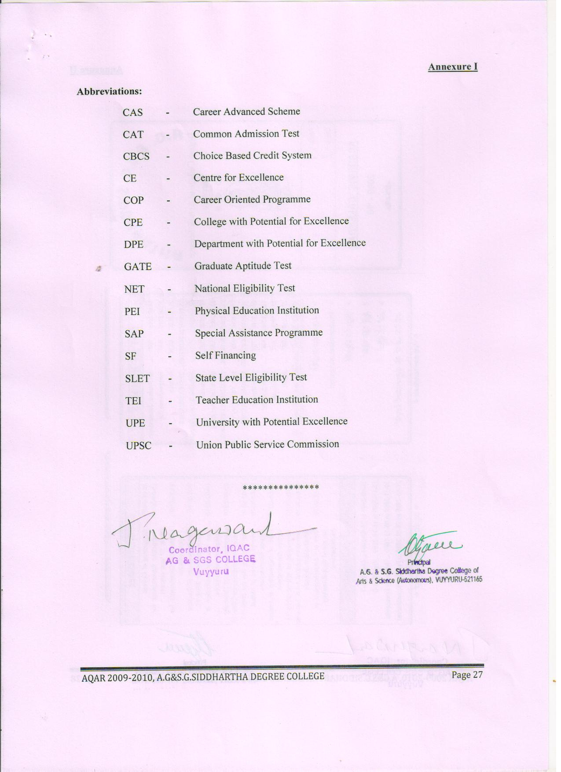

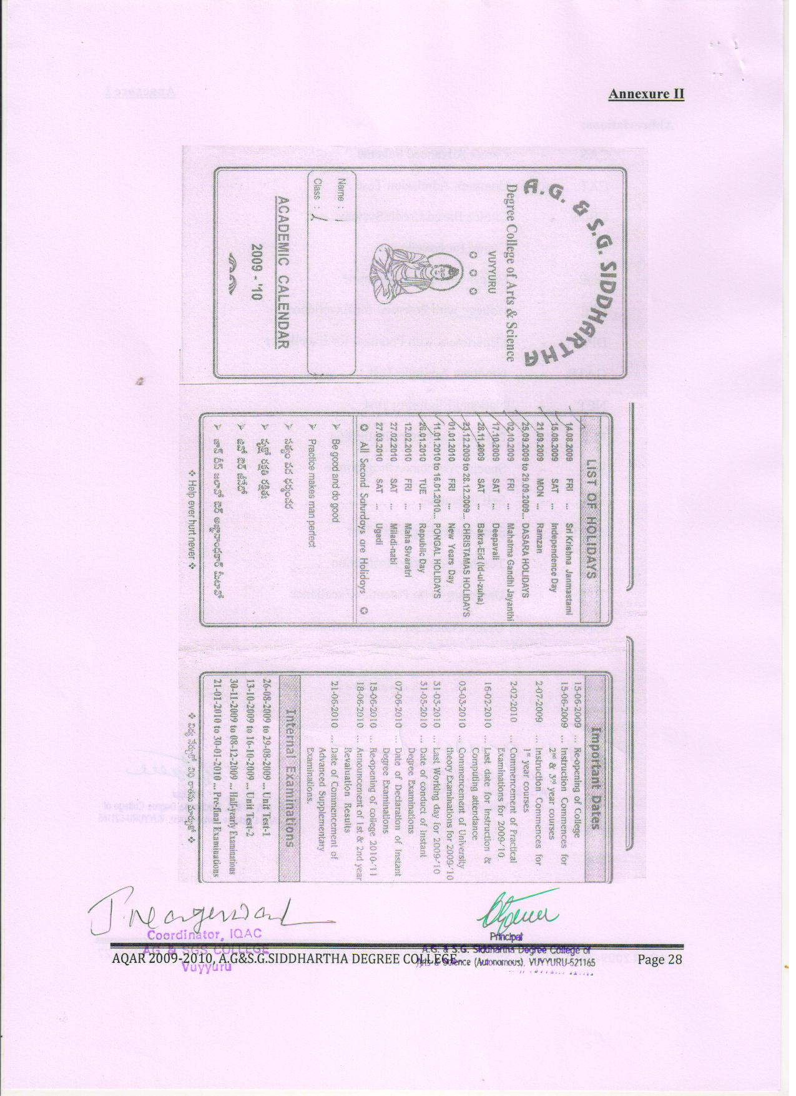

Annexure III
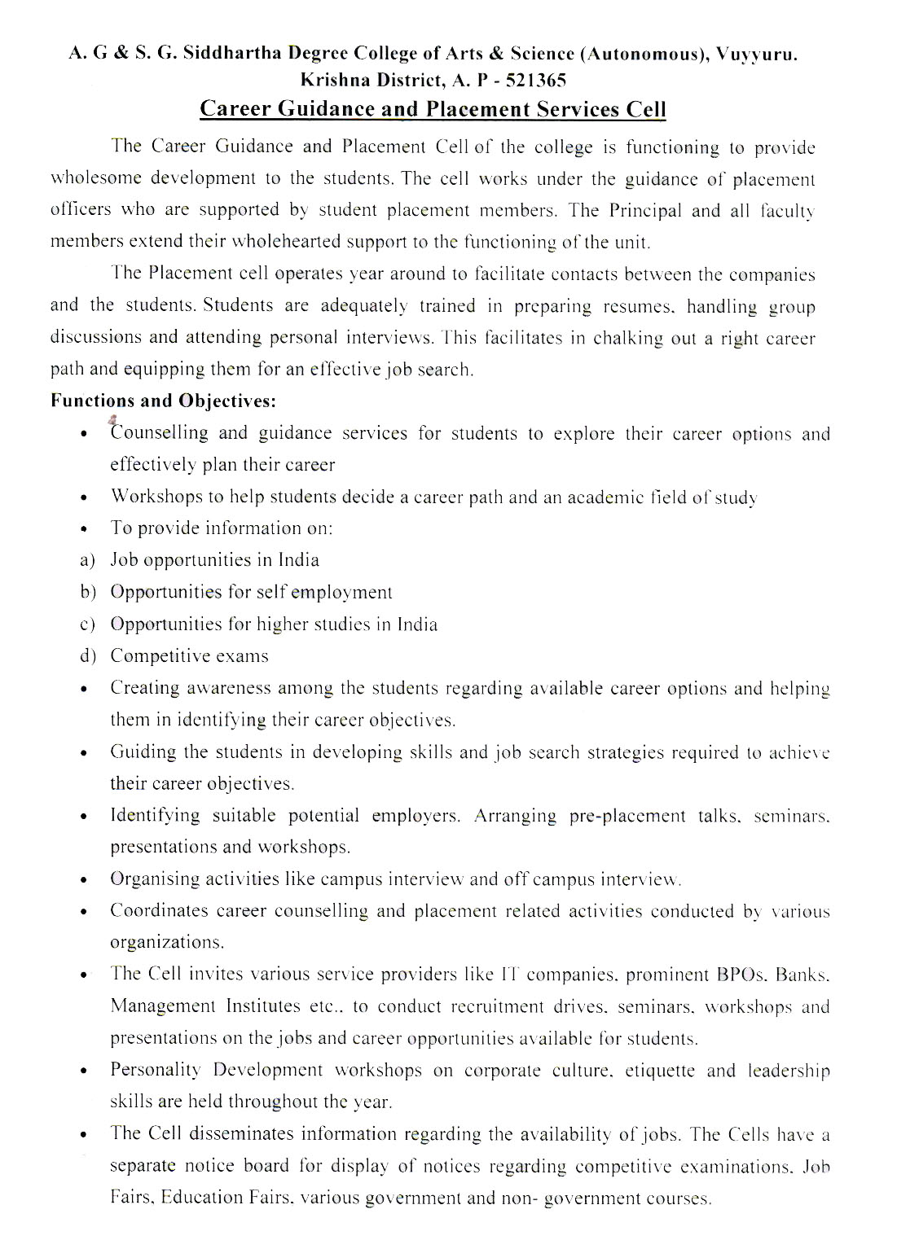

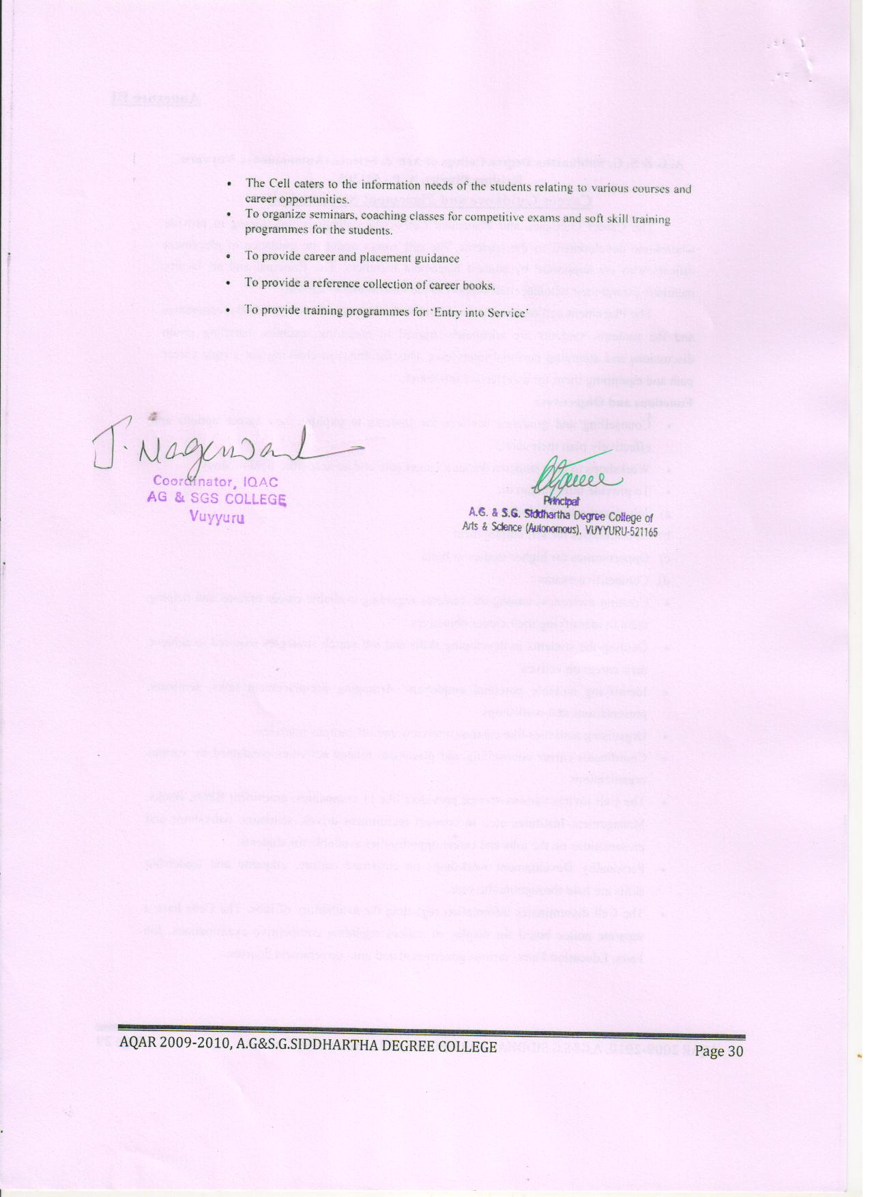

Annexure IV


